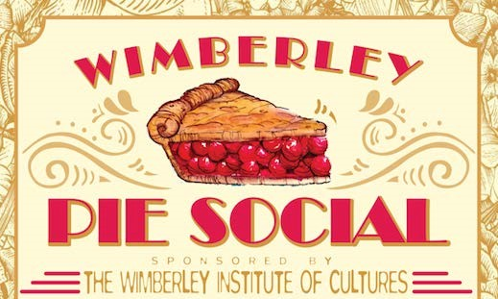
April 23, 2022 ~ 11:00 to 3:00 ~ Wimberley Valley Museum

Pie Contest Rules and Entry Form
- All contest entries must be Homemade.
- You may enter as many pies as you wish.
- Please use non-returnable pie pans.
- Bring pies to Wimberley Community Center from 8:30 ~ 9:30 am.
- Entries will be judged on APPEARANCE, QUALITY and TASTE.
- There will be First, Second and Third place winners in each category.
- One GRAND PRIZE entry will also be chosen.
- Winning pies will be announced and auctioned at the Pie Social.
- CATEGORIES: Nut, Fruit, Cream, Specialty and Kids (12 & under).
- Complete and attach entry form to each pie entered.
- Entry forms also available at Wimberley Visitors Center, Wimberley Village Library and Online at www.WimWic.org
__ __ __ __ __ __ __ __ __ __ __ __ __ _ __ __ __ __ __ __ __ __

PIE CONTEST ENTRY FORM

NAME _____________________________________________________

PHONE _____________________________________________________

EMAIL _____________________________________________________

PIE NAME _____________________________________________________

PIE CATEGORY Fruit ____ Nut ____ Cream ____ Specialty ____ Kids ____

