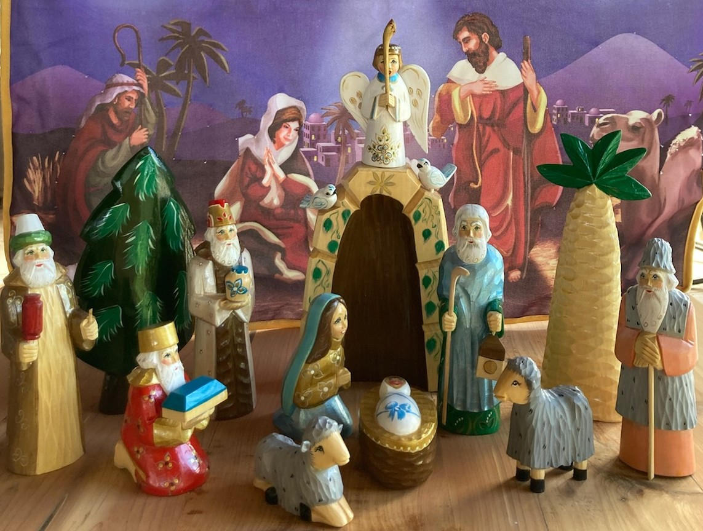
3rd Annual Nativity Exhibit – 2022

November 25, 26, & 27 11 a.m. – 7 p.m.
November 28, 29, 30 & December 1 5 p.m. – 8 p.m.
December 2, 3 & 4 11 a.m. – 7 p.m.

At Red Barn 3187 St. Hwy 35 Port Lavaca, TX

This FREE event will showcase 100s of Nativities from around the world, made from a vast array of materials – round hay bales, corn husks, cinnamon bark, pasta, pinto beans, recycled bottles, terra cotta, banana leaf, hammered tin, stained glass, wax, carved olive wood, lace, yarn and MORE!
Many have a special memory to share – our 1st Nativity as a family, bought while stationed overseas, treasured graduation gift from grandparents, left in attic by previous homeowners, “rescued” from thrift stores and estate sales…
To exhibit, donate or sponsor a Nativity, call/text 361-935-8032 or 361-550-8620.

